Scanning Dashboard Main Form:
The scanning dashboard main form displays the Document Scanner form and provides a menu to other forms within the dashboard.
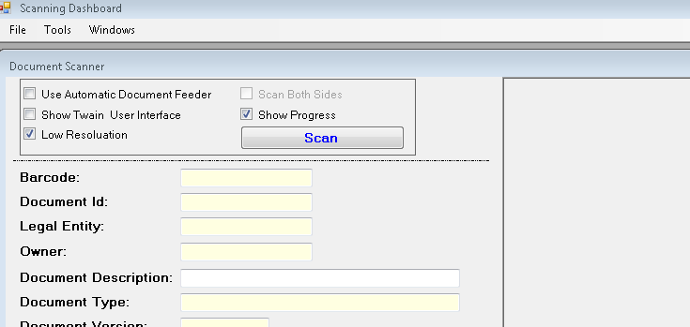

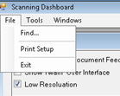 | - Find: Displays a form allowing for the entry of a barcode to find and display the document(s) associated with the barcode.  - Print Setup: Displays a form allowing for the selection of a different printer.  - Exit will close the Scanner Dashboard.
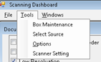 | - Box Maintenance: Allows for creating new boxes, printing box labels or batch labels.  - Select Source: Allows for selection of a different scanner.  - Options: Allow for setting specific options that control the application.  - Scanner Setting: Allow for default values to be displayed on the main scanner form.

Document Scanner Form:
The document scanner form is the form used for scanning documents and unlike other forms this form cannot be closed.
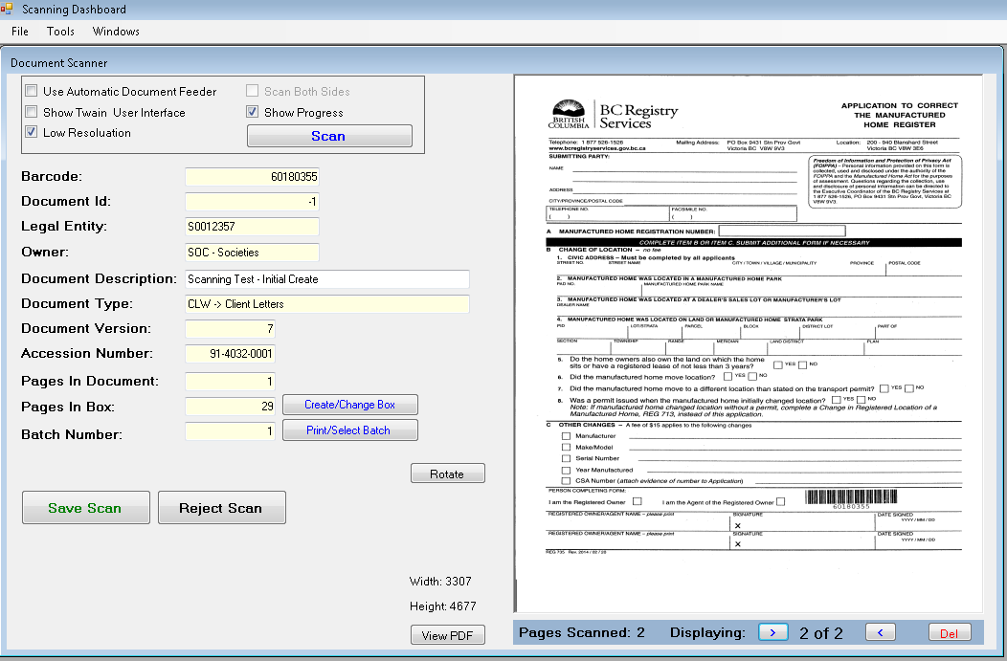
- Checking the “Use Automatic Document Feeder” check box, will enable the “Scan Both Sides” check box.
- Checking the “Show Twain User Interface” check box, will display the user interface as supplied by the vendor. This will allow for adjusting of contrast, resolution, etc.
- The “Create/Change Box” will display a form allowing either a different box to be selected or a new box to be created. This form also allows for printing of a box label.
- The “Print/Select Batch” will display a form allowing either a different batch to be selected or a new batch to be created. This form also allows for printing of a batch label.
- The “View PDF” will convert the images to a PDF document and display it for viewing.
- If there is a page that was scanned and needs to be rescanned with a higher resolution the “Del” button can be used to remove the scanned document. Note: The first document scanned with the barcode cannot be removed. This would require rejecting the scan and starting a new scan.

Twain Scanner Driver Form:
This form is supplied by the vendor and will appear different from vendor to vendor, but the basic features would be the same.
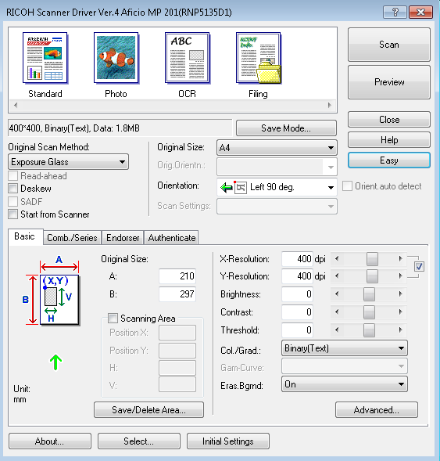
In most cases this form need not be displayed, but there may times when a higher level of scan is needed.

Find Document Form:
This form can be used to look up the document(s) for an existing barcode number.
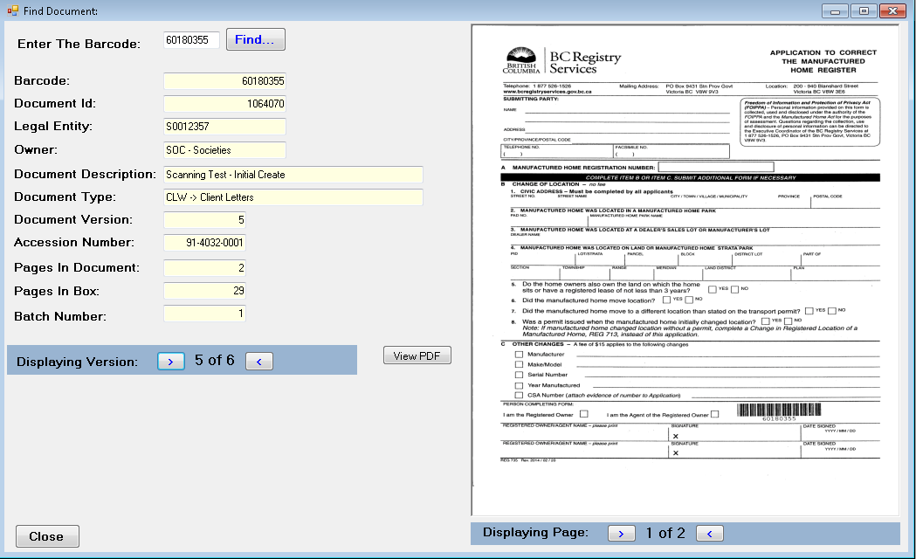
- Multiple versions of this form can be displayed in the main form.
Another Example:
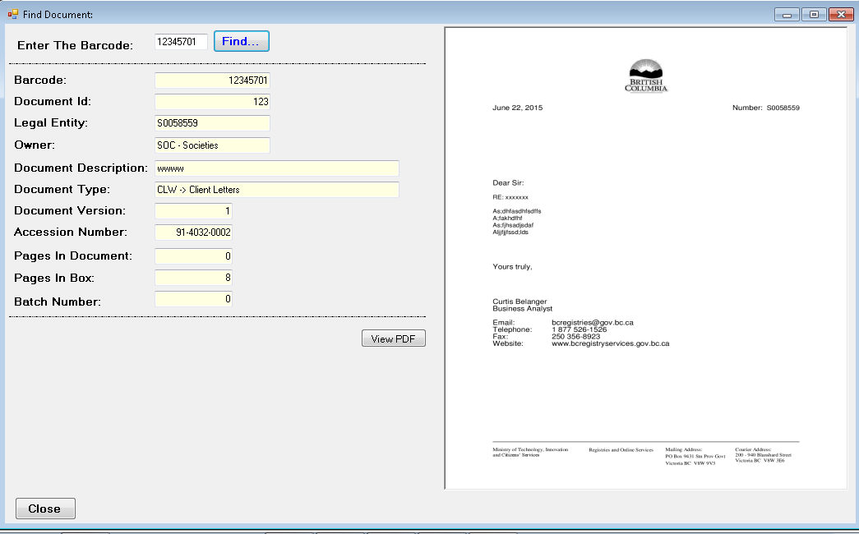

Box Maintenance Form:
The box maintenance form is used to create new boxes, print box labels and/or print batch labels.
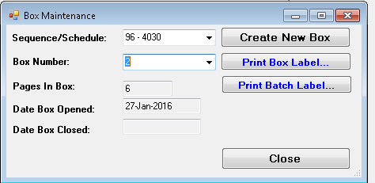
- The “Create New Box” button will close the existing box for the Sequence/Schedule and create a new box.
- The “Print Box Label” button prints the box label for the selected box.
- The “Print Batch Label” button displays the “Print/Select Batch” form prints.
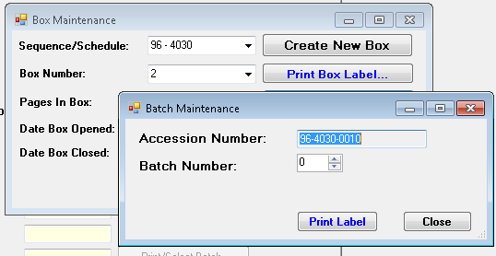

Select Source Form:
This form is supplied by the twain interface component and allows for selection of a different scanner.
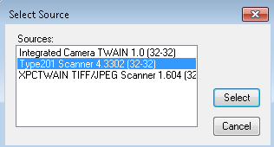

Options Form:
This form is used to set options used in controlling the dashboard.
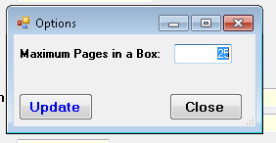
- Currently the only option is the Maximum Pages in a Box option.

Scanner Default Setting Form:
This form is used to define the default values displayed on the Document Scanner form:
